**Assignment 6: *coding***

Q1: Write a java code with the class named ‘acad’ and a method ‘main’. Hardcode the program with two integers and print the sum of those two.

**import** java.util.*;

**public** **class** acad {

**public** **static** **void** main(String args[])

{

**int** a=9;

**int** b=7;

**int** sum=a+b;

System.***out***.println(sum);

}

}

OUTPUT:

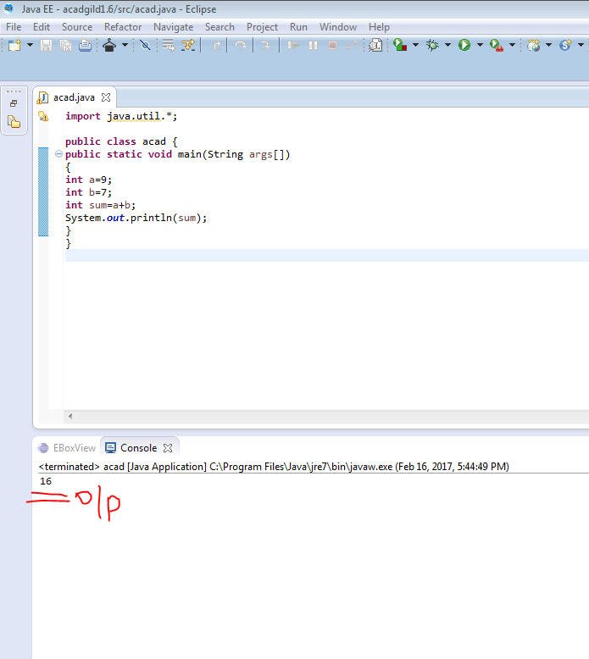

Q2: Rewrite the above code, where, inputs are provided by the user at runtime and the output is printed

**import** java.util.*;

**public** **class** acad {

**public** **static** **void** main(String args[])

{

Scanner s=**new** Scanner(System.***in***);

System.***out***.println("enter the value of a");

**int** a=s.nextInt();

System.***out***.println("enter the value of b");

**int** b=s.nextInt();

**int** sum=a+b;

System.***out***.println(sum);

}

}

OUTPUT:

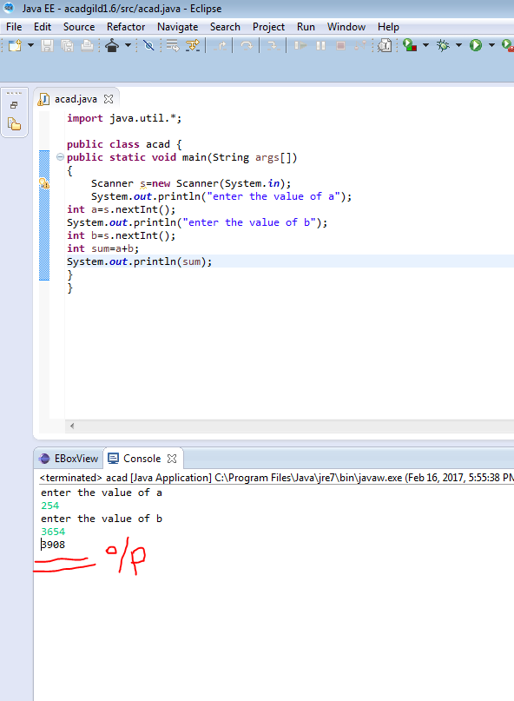

Q3: Write a program with method name sum() that accepts two parameters from user and print the sum two numbers.

**import** java.util.*;

**public** **class** acad {

**public** **static** **void** main(String args[])

{

Scanner s=**new** Scanner(System.***in***);

System.***out***.println("enter the value of a");

**int** a=s.nextInt();

System.***out***.println("enter the value of b");

**int** b=s.nextInt();

System.***out***.println(*sum*(a,b));

}

**public** **static** **int** sum(**int** a,**int** b){

**int** x=0;

x=a+b;

**return** x;

}

}

OUTPUT:  
